Ulike Air 10 vs Laser Hair Removal: Which is the Superior Solution?
Meta description: Ulike Air 10 & laser hair removal offer a truce! I tested BOTH. Let's unpack the mystery and find your superior solution.

Ulike Air 10 vs Laser Hair Removal: Which is the Superior Solution?

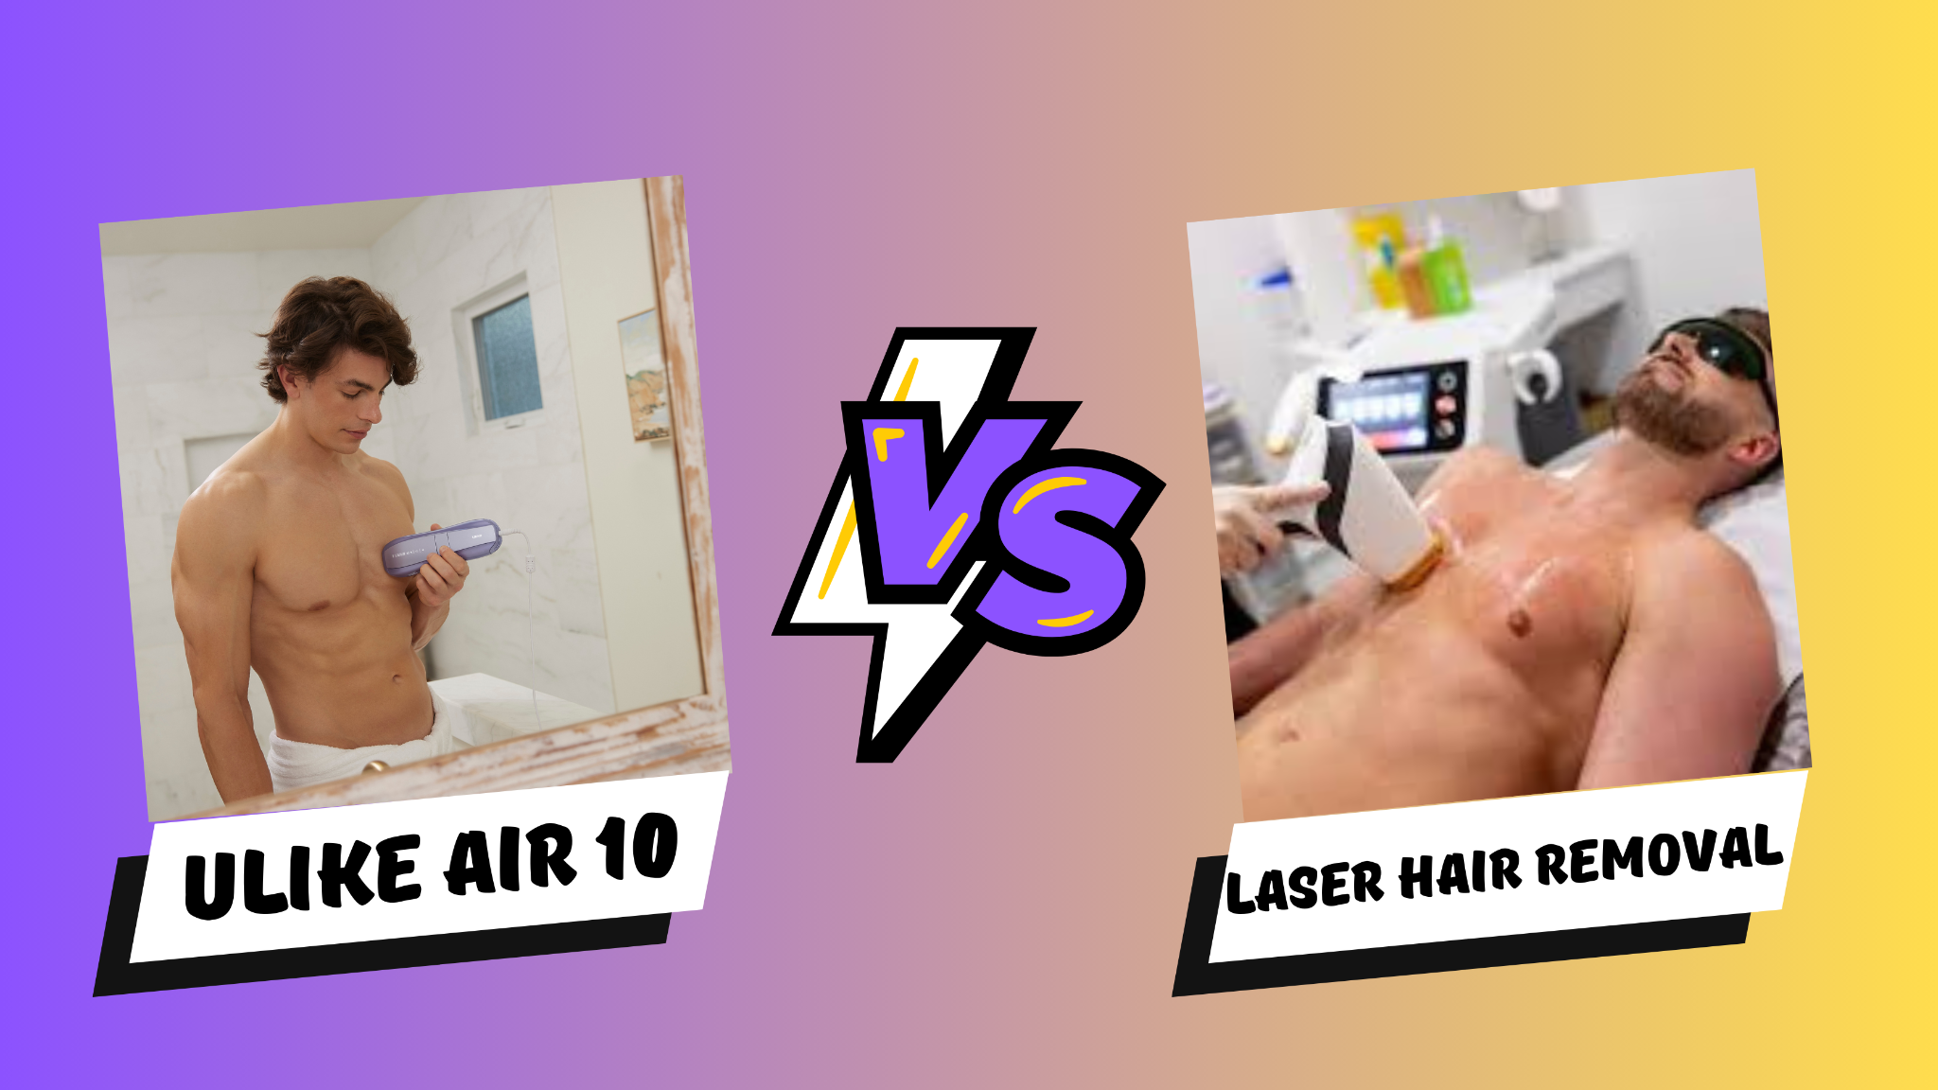

How does Ulike Air 10 Work?
Ulike Air 10 uses targeted light beams to reach hair follicles. The key here is melanin, a pigment found in both hair and skin. The Ulike Air 10 device emits light absorbed by melanin, which gets converted into heat. This heat disrupts the hair growth cycle, pushing existing hair into a resting phase and eventually causing it to shed. It also hinders future hair growth, leading to smoother skin for longer. Want to learn more? Check out the Ulike blog for a detailed review of the Ulike Air Series IPL devices: "Best IPL Laser Hair Removal Machines | Ulike Air Series.”

The thing I love is that Ulike Air 10 targets the melanin in your hair, like a heat-seeking missile for darkness. Think about it - a black car gets hotter in the sun than a white one, right? Same principle here. The darker the hair, the more it absorbs the light, making the follicle take a permanent vacation. The result? Smooth, hair-free skin that makes you feel like a million bucks.

How does Laser Hair Removal Work?
Laser hair removal isn't magic (although sometimes it feels that way), it's science! It uses concentrated light beams to target those pesky hair follicles, basically zapping them into submission. This disrupts their growth cycle, leaving you with less hair, and finer, softer hair that grows back way slower.

Home vs. Salon:
Now, you might be thinking, "Laser hair removal sounds awesome, but isn't it a whole salon thing?" Well, traditionally, yes. But technology has our backs, and there are actually some at-home options available! Products like the TRIA Beauty Laser Hair Removal Device 4X are like little superheroes for your skin. This handy gadget uses a targeted laser (think of it as a tiny light sword for your fuzz) to tackle hair growth at home.

Hair Today, Gone Tomorrow? Demystifying Ulike Air 10 & Laser Hair Removal Options

I decided to look into laser hair removal. But then I heard about IPL, and whoa, choices! If you're stuck between IPL and laser, you're not alone. Let's break down the two and see which one might be the best fit for you, based on your skin and those unwanted hairs!

Painlessness (Ulike Air 10 Vs Laser Hair Removal)
Laser treatments are like getting a VIP pass to pain-free territory. They often use numbing creams, so the laser feels more like a pinball machine on low power than a firestorm. Ulike Air 10 devices, on the other hand, are like little built-in air conditioners, blasting you with cool comfort while they take care of business. It's honestly almost relaxing - like a mini spa treatment where you trade in the frustration of unwanted hair for smooth confidence!

Effects on the skin and hair (Ulike Air 10 vs Laser Hair Removal)
Laser hair removal felt very targeted, which makes sense because it uses a concentrated light source. While this might be effective for faster results, it also meant some temporary redness and irritation for my skin. Ulike Air 10, on the other hand, seemed gentler. There was minimal discomfort after treatments, which was a big plus for me. It did take a bit longer to see a significant reduction in hair growth with Ulike Air 10 compared to laser, but the trade-off for less irritated skin was worth it in my experience

Cost (Ulike Air 10 Vs Laser Hair Removal)
Price was a game-changer in my decision. A single laser session cost as much as some Ulike Air 10 devices! Professional treatments averaged $400-$500 per session, while Ulike Air 10 devices cost $379-$400, but last a lifetime. Plus, you can get an even better deal with code Ulike Air 10: AIR10EARLY (saves $80) getting it at $299-$320 only. Knowing I'd need multiple sessions, laser's upfront cost was prohibitive. In the long run, even if Ulike Air 10 takes longer, it felt like the smarter budget choice.

Time Taken to Show Results (Ulike Air 10 Vs Laser Hair Removal)

Seeing results with Ulike Air 10 was a journey, not an instant fix. There was a definite decrease in hair growth after a few weeks, but it took about 12 weeks of regular treatments to see a real difference in density and thickness. I know some people see faster results with laser, but for me, the gradual approach with Ulike Air 10 was actually a plus. It allowed my skin to adjust to the treatment comfortably, and I could see the progress happening over time, which was motivating.

Factors That Determine Final Decision (Ulike Air 10 Vs Laser Hair Removal)
Picking between laser and Ulike Air 10 wasn't a simple choice. Ulike Air 10 was definitely more versatile - it tackled unwanted hair, and some devices even offered skin rejuvenation benefits, which was tempting. However, speed wasn't my biggest concern.

Honestly, the ongoing cost of laser sessions was a bit of a hurdle for me. While laser might be faster, Ulike Air 10's upfront device cost felt more manageable in the long run. Plus, I was okay with a more gradual approach. Seeing results with Ulike Air 10 took some time, but it allowed my skin to adjust to the treatment comfortably. Consulting a professional really helped me understand all these factors. They explained that Ulike Air 10 might be a better fit for my needs and budget, and that's exactly what I found.

Comparison Table

Features | Laser Hair Removal | Ulike Air 10
Painlessness | Laser (numbing cream, feels like pinball machine on low power) | Ulike Air 10 (cool air, feels relaxing)
Effects on skin and hair | Laser (targeted, faster results, temporary redness and irritation) | Ulike Air 10 (gentler, minimal discomfort, slower results)
Cost | Laser ($400-$500 per session) | Ulike Air 10 ($379-$400 for lifetime use) plus (with coupon AIR10EARLY) you can get it at $299-$320
Time Taken to Show Results | Laser (faster results) | Ulike Air 10 (gradual results, takes 12 weeks)

Conclusion
In the end, Ulike Air 10 proved to be a great solution for my sensitive skin. Traditional methods like shaving or waxing just weren't cutting it anymore. While it took a bit longer to see full results compared to some other options, Ulike Air 10 offered a comfortable and effective way to manage unwanted hair.

Of course, everyone's skin and needs are different. If you're considering laser or Ulike Air 10 hair removal, talking to a professional is a great first step. Ulike Lab can help you weigh the pros and cons of each method and determine which one might be the best fit for you in terms of effectiveness, comfort, and budget.

