**Perfect Brows For Every Face: Ideal Candidates For Eyebrow Microblading**

Discover the secret to flawless brows with our guide on [**eyebrow microblading**](https://santanastudioacademy.com/microblading-in-manati-puerto-rico/)! Learn who the ideal candidates are and how this semi-permanent solution can redefine your look.

Eyebrows are essential in shaping the face and highlighting one's facial characteristics. While some are blessed with naturally thick and well-shaped brows, others may struggle to achieve their desired look.

Eyebrow microblading has emerged as a popular solution, offering a semi-permanent way to achieve flawless brows. This article will explore the art of microblading and identify the ideal candidates for **microblading eyebrows**.

**Understanding Eyebrow Microblading**

Microblading is a semi-permanent cosmetic procedure that involves using a fine blade to deposit pigment into the skin, creating hair-like strokes to mimic natural eyebrow hairs.

This technique enhances eyebrows' shape, fullness, and overall appearance.

Unlike traditional eyebrow tattoos, microblading provides a more natural and realistic result, making it a preferred choice for many beauty enthusiasts.

**Ideal Candidates**

Microblading suits many individuals, but certain factors can make someone an ideal candidate for this procedure.

Let's explore the traits that make someone an ideal candidate for eyebrow microblading.

**Sparse Or Thin Brows**

For those grappling with sparse or thin eyebrows, microblading emerges as a transformative game-changer. The procedure results in well-defined and fuller eyebrows, boosting confidence and providing a prominent facial feature.

This is particularly beneficial for individuals with naturally thin brows or those who have experienced hair loss in the brow area, offering a lasting solution to the challenge of achieving voluminous brows.

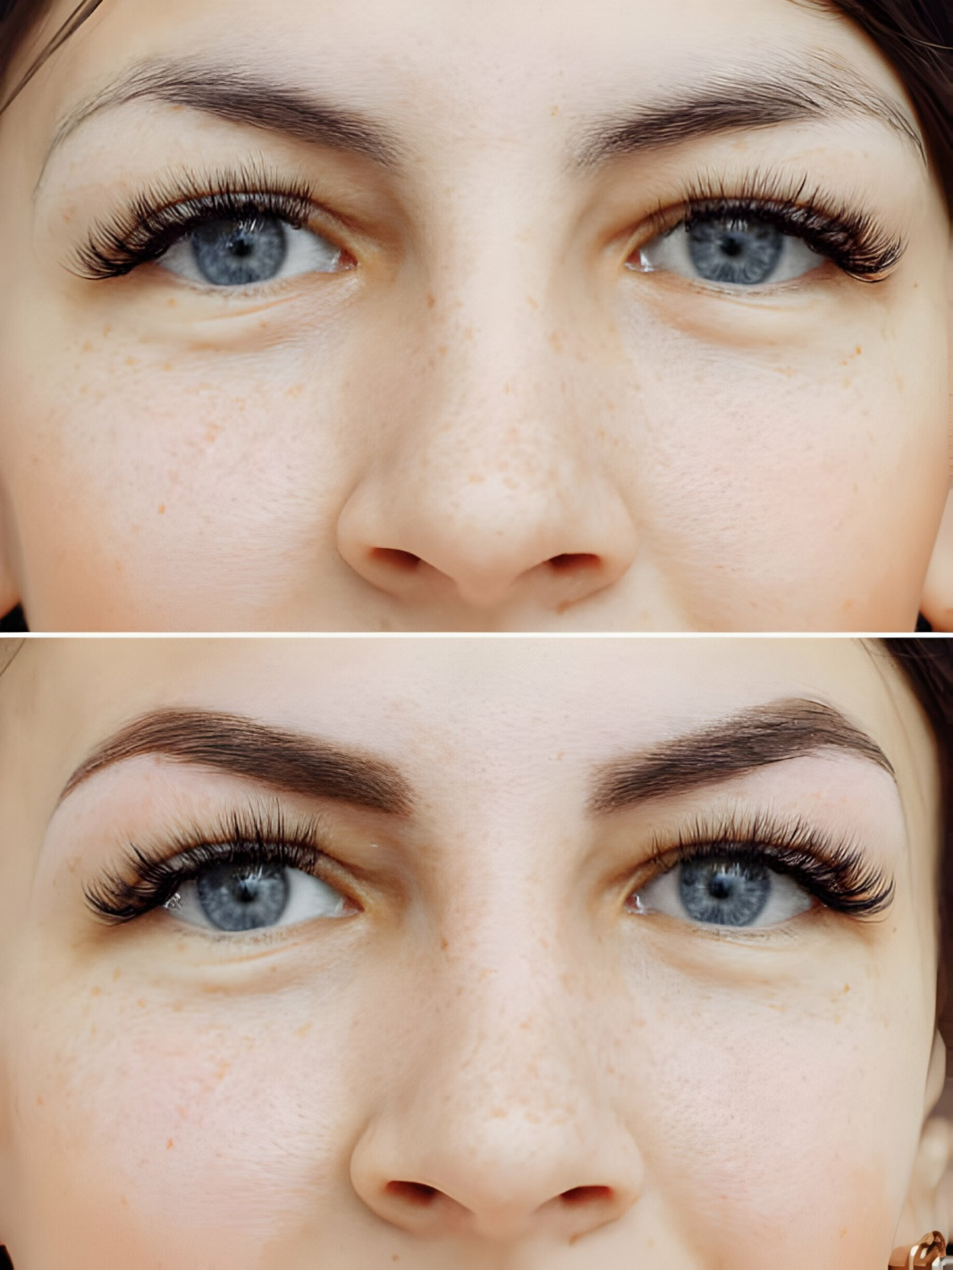

**Uneven Or Asymmetrical Brows**

Achieving perfect symmetry in natural features, including eyebrows, is a rarity. Many individuals contend with uneven or asymmetrical brows, which can be a source of frustration.

Microblading offers a precise and customized solution to achieve balance and symmetry, ensuring that both brows complement each other seamlessly.

**Busy Lifestyles**

Microblading becomes an invaluable option for individuals leading hectic lifestyles, where dedicating time to daily eyebrow grooming is challenging.

The semi-permanent nature of the procedure translates to less time spent on daily makeup routines, providing a hassle-free solution for those with busy schedules.

This convenience aligns microblading with the demands of contemporary life, allowing individuals to maintain impeccable brows without compromising on time.

**Chemotherapy Patients**

Cancer treatments, especially chemotherapy, often lead to hair loss, including eyebrows. Microblading can be a transformative experience for cancer survivors, offering a path to regaining confidence and a sense of normalcy.

By recreating natural-looking eyebrows, microblading contributes to restoring a more familiar and self-assured appearance for individuals who have undergone challenging medical treatments.

**Alopecia Sufferers**

Alopecia, an autoimmune disorder causing hair loss, can extend its impact to the eyebrows. Microblading emerges as a beacon of hope for individuals with alopecia, allowing them to redefine their brows.

This transformative procedure empowers individuals to embrace a look that aligns with their style, helping to alleviate the aesthetic effects of hair loss associated with this autoimmune condition.

**Over-Tweezed Or Over Waxed Brows**

Individuals who have over-tweezed or over-waxed their eyebrows, leading to thinning or an unnatural shape, can significantly benefit from microblading.

This procedure offers a corrective measure, helping to restore a more balanced and aesthetically pleasing brow shape.

Microblading can fill gaps, redefine the arch, and create a natural-looking structure, allowing those with past over-tweezing mishaps to regain confidence in their brows.

**Aging And Loss Of Brow Definition**

As individuals age, the loss of brow definition is a common concern. Microblading is a rejuvenating solution that restores definition and creates a youthful appearance.

The precise application of pigments can counteract the effects of aging, adding fullness to thinning brows and giving a lift to the overall eye area.

This makes microblading a sought-after option for those looking to address age-related changes in eyebrow appearance.

**Allergy To Traditional Makeup Products**

Some individuals may have allergies or sensitivities to traditional makeup products, making daily brow application challenging.

Microblading provides a hypoallergenic alternative, as the pigments are often less likely to cause adverse reactions.

This makes it an ideal choice for those with sensitive skin or makeup allergies, offering a semi-permanent solution that allows them to enjoy beautifully defined brows without the risk of irritation.

**Conclusion**

In conclusion, eyebrow microblading stands out as a versatile and transformative solution for a diverse range of individuals seeking to enhance their eyebrow aesthetics.

Whether individuals address concerns such as sparse or thin brows, unevenness, busy lifestyles, chemotherapy-induced hair loss, alopecia, over-tweezing, aging-related loss of definition, or allergies to traditional makeup products, microblading offers a personalized and natural-looking remedy.

If you're considering eyebrow **[microblading near me](https://santanastudioacademy.com/microblading-in-manati-puerto-rico/)**, choosing a reputable and experienced technician is essential to ensure optimal results.

If you're interested in trying eyebrow microblading to achieve your desired brow look, consider visiting **Santana Studio Academy**.

Our skilled artists are committed to bringing out your natural beauty through expert microblading services in a warm and inviting space.

Head to our website to learn more about our services and schedule your microblading appointment today!